WELCOME

to

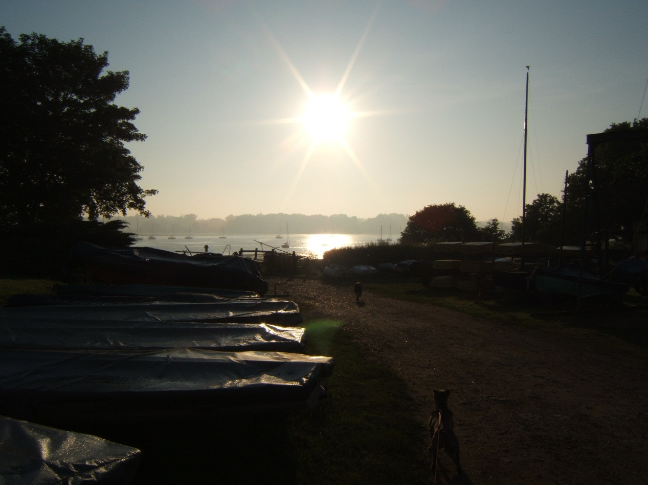

WOOLVERSTONE

Purpose

This leaflet has been produced by the Parish Council and the aim is to encourage a sense of community and provide what we hope will be helpful information on the facilities within the village and advice about life within a conservation area.

The Community consists of over 100 private dwellings, Woolverstone Marina, Royal Harwich Yacht Club, Ipswich High School for Girls, the Village Hall (known as Berners Hall). We also enjoy the benefit of Horseponds Green, a piece of land given to the village which you will find in the middle, on the right just beyond the turn to the Marina

Organisations within the village include

The Parish Council

The Council consists of 9 residents who have been elected by the parish. You can find the name and telephone number of the current Chairman and Parish Clerk by contacting Babergh District Council on 01473 822801 or checking on their website: www.Babergh.gov.uk

The Council meets once every two months to discuss matters relating to the parish, consider the various consultation papers sent by Government departments, local government and their impact on the village and also to consider any planning applications made by residents and the likely effect on the surrounding area and village. The other people who attend the meeting include the Babergh District and Suffolk County Councillors.

The agenda is displayed two weeks before the meeting on the Parish Notice Board which you will find beside the gate on to Horseponds Green. Members of the public are welcome to come along and listen to the discussions.

An Annual Parish Meeting is held in May each year. A report is given on the activities of the Parish Council, as well as reports from Babergh District Council and Suffolk County Council. This is a public meeting to which everyone is welcome.

Berners Hall

Berners Hall, formerly known as the Club Room, when it was a meeting place for the men of the village where most evenings were spent playing cards, darts and billiards and to enjoy beer and cigarettes which they could also buy to take home.
Berners Hall is now our village hall. Apart from being the venue for various village activities during the year, it is also available for private bookings

Booking Secretary: Mrs J Double 780535

Parochial Church Council

The village is very fortunate in having a beautiful church with a warm and friendly atmosphere. The PCC ensure that the building is maintained for the benefit of current and future generations.

Woolverstone Residents’ Association
The Residents’ Association was originally formed to oppose a proposed housing development on the HMS Ganges site at Shotley Gate.

Neighbourhood watch

We are trying to get together a group – would you be interested?

Help!!

This is a small village and all the above amenities which benefit the residents are of great value and need support. It is a good way to get to know everyone within the village. If you feel you would like to contribute in any way to any of the above, please do get in touch with the Parish Clerk.

We are compiling a list of email addresses of residents. This would be such a useful and quick way to pass on helpful information. For example, events within the village, warnings relating to crime, neighbours needing help, changes in bus times, news from our surgery. It could be used in all sorts of ways that would be helpful and of benefit to everyone. If you would like to be included on that list, contact the Parish Clerk.

Woolverstone United Football Club

Woolverstone United play on the football pitch located on the Marina Road.

Holbrook Hornets football club operates for juniors, and matches are played at the Reade Field, Holbrook, (behind the Co-op) on Saturday mornings.

Swimming Club

The Shotley Peninsula Swimming Club provides recreational swimming at Ipswich High School for Girls every week apart from a short break at Christmas. Google “Shotley Peninsula Swimming Club” or make enquiries as follows: Email: SPSC@btinternet.com
Tel: 07546 528 336. Mail: SPSC, c/o Margaret Harward, Stour Haven, Harkstead IP9 1BT

--------------------------------------------------------------------

Additional information about various services provided within the Peninsula

Schools/Educational facilities

Pre School
Chelmondiston Playgroup, Chelmondiston School, Woodlands, Chelmondiston
Telephone 780948

Schools:
Chelmondiston Primary School Telephone 780576
Holbrook Primary School Telephone 328225
Holbrook High School Telephone 328317

Church

St Michaels is one of the churches within the Two Rivers Benefice
There is something on every Sunday – keep an eye on the details of the services and a great deal of other helpful information in the “In Touch” monthly magazine.

Doctor
Kingsland Surgery, Shotley 787435
Holbrook Surgery 328263

Police
Policing on the Peninsula comes under Capel St Mary Police Station
Telephone 613500
Messages for the Community Policeman responsible for the Peninsula can be left on
Telephone 383115

Mobile Library
The mobile library visits Woolverstone every 4 weeks on a Friday at 11:30 for 20 minutes. It stops in the Marina Road. For further details contact Suffolk County Council Library.

Bus

There is a regular bus service from Ipswich – there are 4 bus stops in the village: starting from the Chelmondiston end towards Ipswich, 1 – at the junction with Glebe Lane opposite the road to the Church, 2 – opposite the Marina Road, 3 at the junction with Harkstead Lane and opposite Mannings Lane, 4 - by Home Farm. The Bus number is 202 (Ipswich Buses) and the route into the Town Centre most conveniently takes you past the railway station. The Ipswich Buses website gives the current time table.

Post Offices:

The nearest post office is in Chelmondiston, beside the village car park and is open in the morning week days from 08:30 to 13:00.

Alternatively there are post offices at Shotley and in the Co-op store in Holbook.

Recycling Site

The nearest recycling site is in Portman Walk, Ipswich. There are limited recycling facilities at a site just beyond Chelmondiston towards Shotley on the left, including a skip and recycling bins for bottles etc. This is open every Saturday. There is a charge for non-recyclable items. Bottle Banks can be found opposite the Red Lion in Chelmondiston.

Put out your wheelie bin by 0700 on Wednesday mornings.

Village News

To keep in touch with events in the village and on the Peninsula, join our emailing list. Contact the Parish Clerk on 780731 or blackburn_30@btinternet.com, with your email address. The local newsletter “In touch with … Shotley, Chelmondiston, Pin Mill, Woolverstone & Erwarton” . is delivered on a monthly basis to every household.

About the Village of Woolverstone

Woolverstone was known to exist as a village in Anglo Saxon times when Viking raiding parties frequently came up the Orwell and the name is thought possibly to have originated when a leader of one of these raiding parties, named Wulf, sacrificed a native villager on a glacial monolithic stone which stood near the village – hence Wulf Stone. You will be glad to know that this practice has now been discontinued.

The village has a number of interesting houses including

Cat House: A vital landmark to smugglers on the Orwell. It is so-called because of a china cat displayed in one of the riverside windows to let them know when the coast was clear for the unloading of contraband. In the 18th Century, a well known smuggler, Will Laud, who was the son of a boatman at Languard, was killed in a shoot out at the Cat House.

Woolverstone Hall – now the home of Ipswich High School, a fee paying school belonging to the Girls Public Day School Trust – was built in 1776 by William Berners. Built in the Palladian style it remained in the Berners family until 1937 when it was bought by Lord Nuffield as an investment for Oxford University. In 1946 the then London County Council leased the hall and grounds to rehouse the London Nautical School. In 1958 the estate was sold again and the Hall and about 70 acres of surrounding grounds was bought by the LCC. It was sold to the current owners in 1990.

Woolverstone House – which had been used by Woolverstone Hall School as a boarding house and is now in private ownership, was designed by Lutyens.

The Almshouses, located opposite the road to the Marina, were also built by the Berners family and are interesting particularly because of the two monkeys on the roof of the building. Finding out the significance of monkeys to the Berners family is an opportunity for doing a little research if you are interested in local history and prefer to find out for yourself rather than being lectured to!

As you wander through the village you will notice the number of houses of similar architecture, and you will swiftly realise that the Berners family built these houses for the estate workers. They date from 1868 to 1888 and give the village a strong character. In 1989, recognising the value of the common design and architectural detailing of the houses within the village, Babergh District Council proposed to designate the area as a Conservation Area.

What does living in a conservation area mean to you as a resident

If you plan to carry out any work, not only to your house, but also to your garden e.g. the characteristic 3ft Victorian brick wall bordering many of the properties within the village, we strongly recommend you get as much advice as you can from the Planning Department at Babergh District Council.

In brief, an application to the Local Planning Department has to be made and the following will be required:

- Consent would be required for almost all demolition work (including most boundary walls)
- Six weeks’ notice of intent to carry out any of the following: to cut down, top, lop, uproot, wilfully damage or destroy most trees in a conservation area, in respect of which no Tree Preservation Order is for the time being in force. This includes trees of a minimum trunk diameter of 75mm (3 ins).
- The permitted development rights on residential properties (the amount of development you can undertake without requiring planning permission ) will be reduced significantly, giving the Planning Authority greater control over new development in the area.
- The Council will be able to secure a higher standard of design on extensions to existing buildings and new buildings to ensure they acknowledge the vernacular architecture of the area and are constructed of materials common to the locality.
- Permission is also needed before you can install CCTV cameras, satellite dishes in particular locations, put in dormer windows, or building with stone, artificial stone, plastics, timber or tiles. Permission should be sought for such things as solar panels.

These controls are aimed at maintaining the special character and appearance of the area which tends to increase the value of the properties within it. The Planning Control department offers free advice on any issues relating to conservation areas.

The benefits are that the historic and interesting features of the village are protected.

Conclusion

This may be a small village but one of great character and positioned in beautiful countryside. Once people move in, they tend to stay.

We hope you will be happy living here.

For further information contact the Parish Clerk on 01473 780731

