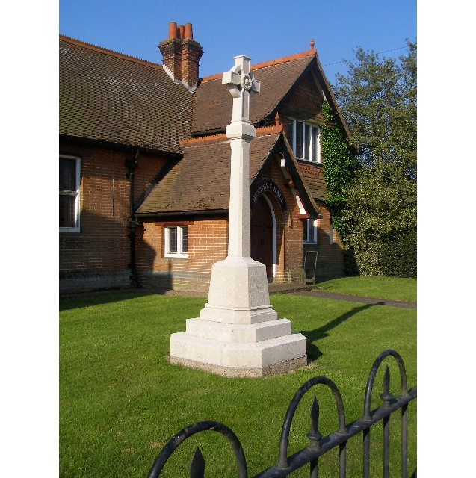
MINUTES
Meeting of the Woolverstone Parish Council
Thursday 12th September 2024, 7.30pm at Berners Hall

- Apologies: Jamie Mayhew, Kathryn Deaton, Simon Harley(SCC) and Daniel Potter (BDC)
- Attendance: Simon Pearce, Anna Caston, Allison Glading, Simon Kent, Matthew March, Sarah Harris, Penny Speller
- Declaration of any prejudicial interest: none.
- Meeting Open to Parishioners: none
- Minutes
11th July 2024 – proposed –Allison Glading, seconded – Penny Speller
- Matters Arising
SP sent three emails to Chris Price (Chelmondiston PC) regarding the B1456. He has not yet received a reply.
CIL money for the walled garden is being chased by Simon Pearce.
The planning application objection relating to Barrelman’s Point (former Ganges) has been sent by SP on behalf of the Parish Council. SP has asked Simon Harley to review the Travel Plan as there is no real alternative to using a car - response pending.
PROW will be covered below.
B1456 speed limit application decision- Simon Harley has spoken to SCC legal advisor and intends to make this a matter for discussion at a council meeting. No update on this.
- Reports from District and County Councillors
Daniel Potter – District Councillor
Not present. September Report had been circulated prior to the meeting and the PC is encouraged by the proposed Simpler Recycling Strategy. Other points were noted.
Simon Harley – County Councillor
Not present. September Report had been circulated prior to the meeting. Points were noted.
- PROW – Update
SP reported a positive response from the SCC Definitive map team. An alignment has been found which is acceptable to both parties. SP to check with PROW on the proposed width of the path.

- Elspeth Iskander's Presentation
This was discussed in detail. The aim is to find a way to build a small number of affordable/social housing in Woolverstone. As a way forward, SP will contact BDC Planning to explore options for this proposal. SP will contact Shotley PC to gain more details of their Chapel Fields project.

- B1456 30mph Traffic Calming Project
Additional SID devices and additional signage for the village. SP presented his initial research. More detailed analysis will be available at the next meeting. KD will be responding to the proposal to fund 30mph bin stickers.
SP has contacted Easton Parish Council and asked for some further details on how their process was started. No response as yet.
SK to present a design idea for Woolverstone road signs based on the successful Easton village road sign design.

- Working Groups: Horsepond’s Green – Update
In the Spring the scrub was cleared and the dead silver birch was taken down. Logs were stacked. In mid-summer, nettles were cut down to create a clear sunlit area. The next stage is for a working party to undertake clearance work following the guidance set out in the Management Plan written by Suffolk Wildlife.
This will take place on Saturday 12th October. The village community are to be informed through the newsletter.
A company based at Home Farm, 0KoHaus UK, have been in contact in order to explore collaboration on biodiversity projects. SK to respond.

Heritage Plaques: SP to present at the next meeting.

- Finance – Allison Glading
Currently our balances are:-
Parish Council £2951.78
CIL £7287.85
Lottery £4916.30
The CIL and lottery grant funds remain unchanged.
For the Parish Council, the SALC membership payment of £185.27 has been made and £82.80 for dog bin emptying. A payment of £287.60 has been received from Friends of Woolverstone as a donation towards the D Day boards.
We are expecting a further donation of £215.70 from the Babergh District Councillor's fund. SP to contact Daniel Potter.
Insurance payment of £168 is due and I will be looking for approval at the Parish Council meeting.
An invoice of around £135 for election charges is expected.
Precept payment of £1550 is due from BDC later this month.
VAT currently amounting £180.60 will be claimed towards the end of the financial year.
- Correspondence
Sunday 22nd September, the road will be closed due to the half marathon from 9:30 am until 1:00 pm.
National Beach Clean – 28/29th was agreed.
Police Forum - 18th Oct at Wherstead village hall. 7:30pm
Water testing around the Peninsula to continue next year - financial contribution of £50 agreed.
NPPF changes consultation on planning reforms - Parish Councils included in this response request.

- Planning: Wherstead A14 junction Service Station. The PC wished to respond to this application in support of Wherstead PC's response. SP to reply.

- Berners Hall
The lead covering to the bell canopy is being repaired. The supporting legs are also being replaced.
- 16. Friends of Woolverstone
Art Show – 14/15th September. Full booking of artists. Christmas Fayre - 30th November
- AOB
MM presented apologies in advance of the next meeting.
JM's absence meant that an update on the coastal path could not be given in response to MM's question at the previous meeting.

Date of next meeting: 10th October 2024
Meeting closed at 21:30

Signed:
Simon Pearce. Chairman.

