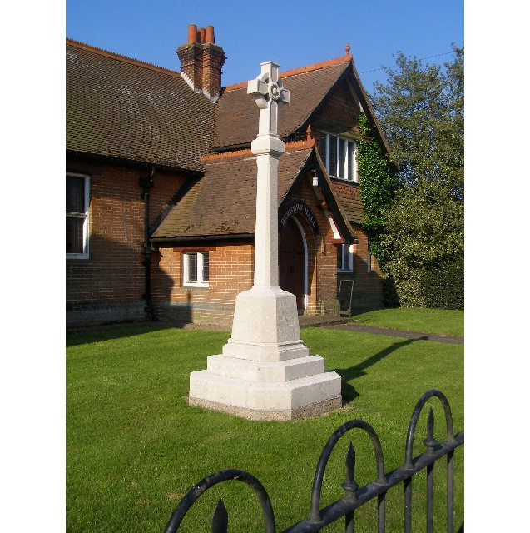
MINUTES
Meeting of the Woolverstone Parish Council
Thursday 14th November 2024, 7.30pm at Berners Hall

- Apologies: Allison Glading, Anna Caston
- Attendance: Simon Pearce, Kathryn Deaton, Simon Kent, , Penny Speller, Matthew March, Simon Harley (SCC), Daniel Potter BMSDC) Elspeth Iskander (Parishioner).
- Declaration of any prejudicial interest: none.
- Meeting Open to Parishioners
This is detailed under item 7.
- Minutes
10th October 2024 – proposed – Sarah Harris, seconded – Penny Speller
- Matters Arising
All points will be covered in the meeting.
- Affordable Housing for Woolverstone – Matthew March and Elspeth Iskander
MM and EI attended a meeting on social housing. A detailed report and documents were circulated in advance of the PC meeting detailing what was learnt. If land can be found both Matthew March and Elspeth Iskander would support this being progressed.
Penny will do some research on Hastoe who are the builders / charity that was recommended. Matthew March and Elspeth Iskander will explore options in securing land.
It was suggested that the PC vote on whether we progress this further. It was unanimously agreed.
- Reports from District and County Councillors
Reports were circulated in advance of the meeting. Any questions will be emailed as neither were in attendance.
Daniel Potter – District Councillor
The report was circulated in advance of the meeting.
Simon Harley – County Councillor
The report was circulated in advance of the meeting.
Simon Pearce asked how to report the tree roots through the path. Simon Harley advised this was done online.
- PROW Update – SP
An update was given on the progress of Footpath 29.
- Additional SID devices and additional signs for the village – SP
Simon Pearce recommended we buy the special offer SID’s from Elan City with £1000 off per SID. These are solar/battery powered.
Matthew March proposed we go ahead with this and Penny Speller seconded this. It was agreed. Simon Pearce will send a formal email and quote to Simon Harley for a contribution to this cost.
Signs have fallen or are missing. Simon Pearce advised they are in a state of disrepair.
- Widows Homes – BDC Care and Maintenance – SP
A list of questions was submitted to BDC and a full response received. These were circulated in advance of the PC meeting.
- Village Event – SK
Simon Kent suggested a village event in Berners Hall in the autumn. He suggested this could be organised by Friends of Woolverstone. Simon Pearce stressed this would need someone to take a lead on this.
- Risk Assessments – SH
Sarah Harris advised according to our insurance policy we are covered but we must have a risk assessment in place. Sarah Harris will complete these.
- Working Groups – Update.
Horsepond’s Green – there was a very successful session in November. The next session will be Saturday 11th January 1030 – 1230. We will bring mulled wine, coffees, mince pies and cakes. Stay for a chat and social.
We need to purchase bird boxes / bat boxes etc. There will also be a sign advising the history and that it is a village owned area of land. It was agreed.
- Finance - AG
Since last month a donation of £250 from the Babergh District Councillors fund in respect of the boards for the Berners weekend and £60 paid for WPC website hosting.
An invoice of around £135 for election charges is expected.
Remembrance Day wreath £24.99.
Current balances:
Parish Council £4516.98
CIL £7287.85
Lottery £4916.30
VAT of £180.60 will be claimed towards the end of the financial year.
- Correspondence
King Charles III footpath way markers are now in place.
Thanks to Graham Speller for collecting trees.

Correspondence from the previous month was reviewed.
- Planning
None
- Berners Hall
Belfry and roof tiles restoration has been completed.
Boiler has been serviced.
- Friends of Woolverstone
Christmas Fair is the next event Sat 30th November
- AOB
Charity Support to be added to the next meeting agenda.
Date of next meeting: 12th December 2024
Meeting closed at 2125
Signed:

Simon Pearce. Chairman.

