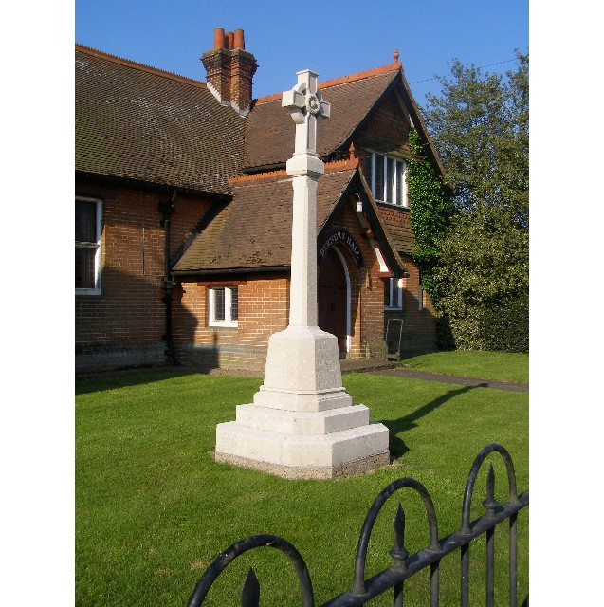
MINUTES
Meeting of the Woolverstone Parish Council
Thursday 11thApril 2024, 7.30pm at Berners Hall

- Apologies: Penny Speller, Sarah Harris, Matthew March, Simon Harley
- Attendance: Simon Pearce, Kathryn Deaton, Anna Caston, Allison Glading (for finance only as unwell), Simon Kent, Jamie Mayhew
- Declaration of any prejudicial interest: none.
- Minutes
14th March 2024 – proposed - Jamie Mayhew, seconded – Simon Kent
- Matters Arising
Speed Report – we have until 10th May to add anything to the report. Woolverstone Parish Council report is being added as an appendix, however Chelmondiston Parish Councils comments as shorter are in the report.
- Reports from District and County Councillors
Reports were circulated in advance of the meeting. Any questions will be emailed as neither were in attendance.
Daniel Potter – District Councillor
Not present.
Simon Harley – County Councillor
Not present.
- PROW – Update – Simon Pearce
Simon Pearce supported this being resolved so that all parties involved can move on following a decision being made by the County Council.
- Working Groups – Update.
(Simon Kent) The Pond – the grant has been approved but we will need a report from Suffolk Wildlife Trust to support this.
Phil Mayhew has been in and cut down the silver birch tree and made insect hotels. The PC thanked Phil Mayhew for this help.
Dates for a working group are to be set and volunteers sought.
(Simon Pearce) Blue Plaques – The Heritage department have advised installation possibilities and asked for photographs of possible locations so they can confirm.
(Simon Pearce) Information Boards – work is underway and agreed these will go to IHS and then Holbrook Academy. They will include photographs and memories. Simon Pearce is asking various parties to sponsor the boards.
- Finance
Draft financial report circulated in advance of the AGM in May.
Allison ran through the accounts and asked for comments and questions. Jamie Mayhew suggested we ask villagers what they wished to spend CIL money on.
Simon Pearce will draft wording for the newsletter and this will then be advertised by Kathryn Deaton on Facebook.
- Correspondence
Covered within the meeting.
Simon Pearce attended a joint Parish Council meeting. This is good in principal but work needs to be done on ensuring the shared knowledge is used.
Simon Harley is funding water testing in the rivers around the peninsula. Woolverstone and Holbrook have e-coli. This will be discussed further at the next meeting.
- Planning
Tree work has been completed by MDL.
- Berners Hall
Lead has slipped on the roof and needs work. Simon Pearce will speak to Sarah Hutton as this could be a safety issue.
They are due to hold an AGM.
- Friends of Woolverstone
There is to be a meeting in May to organise the art show and May event.
- AOB
RHYC to Pin Mill path – Simon Kent has outlined the issue to National Landscapes with the proliferation of new paths being generated by people given the poor conditions underfoot.
Banners at Spring Lodge and IHS – Simon Kent raised this on behalf of his neighbour. He has established that In conservation areas planning is required so he has contacted Babergh Planning.
ESO East Anglia Network Study – Simon Kent will send this to Simon Pearce for inclusion in the newsletter.
Date of next meeting: 9th May 2024
Kathryn Deaton tendered her apologies in advance.
Meeting closed at 2055
Signed:
Simon Pearce. Chairman.

