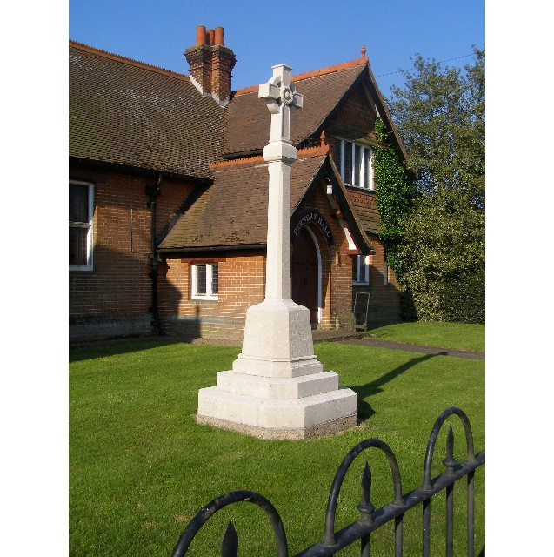
MINUTES
Meeting of the Woolverstone Parish Council
Thursday 11th January 2024, 7.30pm at Berners Hall

- Apologies: Jamie Mayhew, Sarah Harris, Daniel Potter.
- Attendance: Simon Pearce, Kathryn Deaton, Anna Caston, Simon Harley, Penny Speller, Allison Glading, Matthew March, Simon Kent, Matthew March.
- Declaration of any prejudicial interest: none.
- Minutes
14th December 2024 – proposed – Matthew March, seconded – Simon Kent
- Matters Arising
Simon Pearce had meeting with Kevin Smith, Operations Director at IHS. He advised JH Global who own the boarding house are in discussion with Mr and Mrs Marshall, this is now with the lawyers. They also discussed damage to the listed enclosure opposite Holbrook Lodge that needs repair due to damage by the builders; the replacement of the gates by ST Michael’s that are not complying with planning permission and the removal of footpath obstruction across The Dairy.
Simon Pearce wrote to Geoff Mayhew asking about the sageguards relating to the sale of the land in Woolverstone.
There is a new timer at Spring Lodge to ensure they are not on all night. This now complies with their planning permission.
- Reports from District and County Councillors
Reports were circulated in advance of the meeting.
Daniel Potter – District Councillor
He was not present and no report was received.
Simon Harley – County Councillor
There is going to be an approximate 65 million deficit in SCC funding over the next two months. There will be significant cuts.
- Finance. Precept to be completed – Allison Glading
Discussion followed over what we should apply for in 2024/2025.
Allison Glading proposed - £3100. Kathryn Deaton seconded.
- Public Right Of Way – Simon Pearce
It is an offence to block a Public Right of Way.
Suffolk County Council replied to Simon Pearce and advised this was not a priority as it was felt to ”not deemed to be a priority at this time.”.
The Highways Act, 1980, Section 103, advises that we can make a representation to SCC Highways to enforce the Public Right of Way and ensure access. They have a “duty” to follow this through.
Simon Harley advised that in an adjacent parish they had a similar issue. He was interested in understanding the Highways Act further and receiving the links.
Matthew March proposed that Simon Pearce contact SCC, This was seconded by Simon Kent.
- D Day – 80th Anniversary – 6th June 2024
At 9.15pm the Beacon will be lit at IHS. From 8.30pm the school will open and be serving coffees to villagers who wish to attend. There will be readings and poetry on the evening.
Simon Pearce suggested we have an exhibition of photographs and information on the weekend of 8th and 9th June at Berners Hall. It was agreed.
- Facebook Update – Kathryn Deaton and Sarah Harris
Simon Pearce thanked Kathryn and Sarah for their work on the Facebook page. The Parish Council were asked to invite friends to follow the page – Woolverstone Village. Link also to be provided in Woolverstone News.
- Lottery Grant. Next Steps – Simon Pearce
We have funds left. Simon Pearce will contact the Lottery handler and ask if this money can be used elsewhere.
We are still to produce a website. This would work in conjunction with blue plaques that will be placed around the village with some information and a QR Code. 18 plaques will be required. SP will come back to the next meeting with further information.
- Village Action Plan to May 2024 – Simon Kent
Simon Kent has nearly finished the document. He asked that this be reviewed once completed and it be used as a working document. This will include the individual responsibilities. It will be a live document.
- Glebe Lane
All issues have to be logged online on the reporting tool.
It was decided that we would not pursue the signs stating “unsuitable for HGV’s” Further liaison will take place with the local farmers.
- Correspondence
Various correspondence.
- Planning – Hamilton House – Tree Works
No objections.
- Berners Hall
Sarah Hutton is continuing to manage bookings.
- Friends of Woolverstone
A repeat of the cine film has been requested. It was agreed this would be Friday 17th May.
- AOB
Date of next meeting: 8th February 2024
Meeting closed at 21:15
Signed:
Simon Pearce. Chairman.

