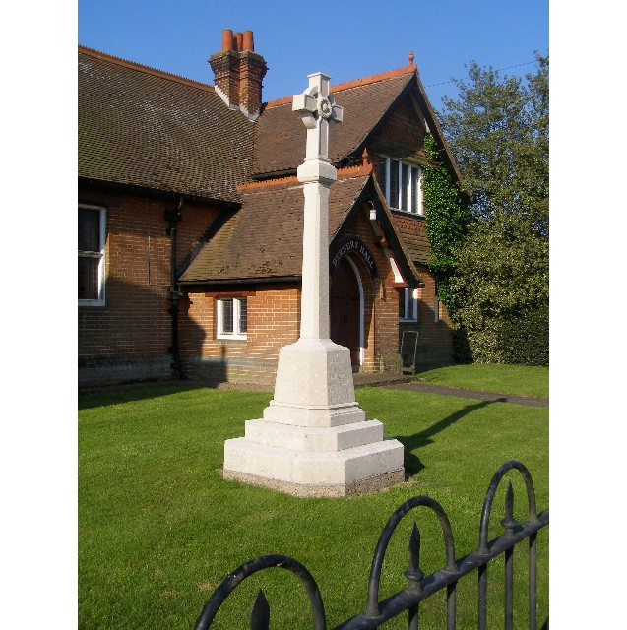
MINUTES
Meeting of the Woolverstone Parish Council
Thursday 13thJune 2024, 7.30pm at Berners Hall

- Apologies: Simon Kent, Daniel Potter, Allison Glading
- Attendance: Simon Pearce, Kathryn Deaton, Penny Speller, Matthew March, Jamie Mayhew, Agi Seemungal from Spring Lodge, Simon Harley arrived after point 10 and point 8 was discussed further.
- Declaration of any prejudicial interest: none.
- Meeting Open to Parishioners – Elspeth Iskander – Berners Hall
Postponed.
- Minutes
9th May 2024 – proposed – Penny Speller, seconded – Jamie Mayhew.
- Matters Arising
B1456 – Covered below.
D-Day Exhibition – this was a huge success. A PDF of the boards will be uploaded so this can be viewed on the Parish Council website and Facebook groups. Simon Harley and the Parish Council thanked Simon Pearce and Sarah Harris all of their hard work in putting this together. This was echoed by everyone. Simon Pearce in turn thanked everyone who helped.
AGM – this ran smoothly.
Council Houses – one house is now vacant.
- Reports from District and County Councillors
A report from Simon Harley was circulated in advance of the meeting.
Daniel Potter – District Councillor
Not present.
Simon Harley – County Councillor
Not present at this stage. Discussion followed over the report.
Simon Pearce will advise the villagers on the water quality through the village newsletter. It was confirmed that the Parish Council would be happy to contribute to the ongoing costs for testing the water quality.
- B1456 Speed Reduction Report. Decision. Next Steps?
Simon Pearce has sent a freedom of information request relating to discussions and how decisions were made on the outcome to not extend the 40 mph between Woolverstone and Chelmondiston.
Simon Harley has complained to the Chief Executive that this was an undemocratic decision behind closed doors.
Simon Harley advised that a member of the public can go to a council meeting and question the cabinet on a topic. The question has to be sent in writing in advance of the meeting. A villager in Chelmondiston is due to attend the next meeting and question the decision not to support the 40mph limit.
- PROW – Update – Simon Pearce
The temporary PROW manager has made an appointment to meet with the owners of Deer Park Lodge. The Parish Council will await the outcome of the meeting.
- Horsepond’s Green – Updates
Simon Pearce has sourced a copy of the original document confirming the purchase of Horsepond’s Green by the Parish Council for the village.
Key immediate points to note:
The oil interceptors need to be maintained by Suffolk County Council. .
The fencing between Horsepond’s Green and Soundings belongs to Soundings and should be maintained by the owner of that property.
There is a restrictive covenant on the land, detailing how this may be used.
- Working Groups – Update.
Simon Harley thought the D-Day exhibition was excellent, as per the minutes above.
Footpath RHYC to Pin Mill – Jamie Mayhew is to discuss this with Phil Mayhew.
- Finance
As reported at the AGM.
Simon Pearce will query the CIL money outstanding for the Walled Garden.
Stickers for 30MPH to go on wheelie bins, solar batteries for the speed cameras and average speed cameras to be added to next month’s meeting agenda.
- Correspondence
Babergh Mid Suffolk Election notices added to the noticeboard.
Stag Beetle workshop – Simon Kent is to attend.
SCC will not continue to fight the spine road variation at Barrelman’s Point.
Police forum – mainly Pinewood, Hadleigh and larger areas.
Our pond is to be surveyed in relation to the water main being laid by Anglia Water.
- Planning
Ganges variation relates to the spine road. Condition N27 in the new planning is in conflict with the original planning. Impact of traffic in a conservation area. Simon Pearce will send an objection.
- Berners Hall and Friends of Woolverstone
Art Show (14/15th September) and Christmas Fayre (30th November) planned.
- Penny Speller asked if the poppy wreath would be brought in. Simon Pearce will look to fix this so it does not flip.
- AOB
Date of next meeting: 11th July 2024
Meeting closed at 21:13
Signed:

Simon Pearce. Chairman.

