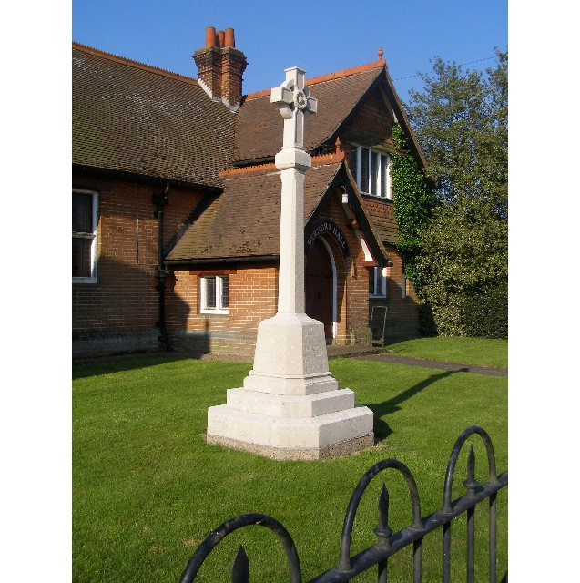
MINUTES
Meeting of the Woolverstone Parish Council
Thursday 13th March 2024, 7.30pm at Berners Hall

- Apologies: Anna Caston, Penny Speller, Matthew March, Daniel Potter
- Attendance: Simon Pearce, Kathryn Deaton, Allison Glading, Simon Kent, Jaime Mayhew, Sarah Harris, Simon Harley,
- Declaration of any prejudicial interest: none.
- Minutes
8th February 2024 – proposed – Sarah Harris, seconded – Simon Kent
- Matters Arising.
Woolverstone PC has joined the Open Spaces Society.
Simon Pearce thanked Simon Kent for reporting water on the road from Horsepond’s which seems to have improved.
Digestate entrance is due to be constructed w/b 08/04. A quote has been accepted.
Glebe Lane has been swept but it has rained since so the mud has built up again. Jamie Mayhew was thanked for his continued support with this.
- Reports from District and County Councillors
Reports were circulated in advance of the meeting.
Daniel Potter – District Councillor
He was not in attendance and Simon Pearce asked for any questions to be emailed.
Simon Harley – County Councillor
Statutory responsibilities must be kept so money has been moved to statutory areas.
Simon Harley ran through the key points.
Simon Kent asked what counted as a County Council sign. This is predominantly speed signs. He asked if direction signs were included but Simon Harley did not believe so.
- B1456 Speed Limit Report – Update Simon Pearce
WPC response sent to SCC. Copy available on the Woolverstone Parish Council website.
- Public Rights Of Way – Update Simon Pearce
Simon Pearce is going to meet with residents of Deer Park Lodge and will report back after this.
- Working Groups – Updates
Horsepond’s – thanks to Sarah Harris and Simon Kent for meeting and discussing this area then to Simon Kent for applying for a grant for the area.
Facebook – we now have 34 followers. Sarah Harris and Kathryn Deaton will continue to post and look to grow numbers.
Blue Signs – Simon Pearce is looking to transfer lottery money that wasn’t used for boards towards improved blue plaques. SP has contacted BDC Heritage for advice re. siting.
- Parishioner requests / proposals.
Kris Meadows suggested a database of equipment that could be shared. Sarah and Kathryn agreed this would be held as a PDF and loaded on the Facebook site.
Ed Bastow questioned if anything could be done to the footpath from RHYC to Pin Mill. Discussion followed on who could potentially fund some boardwalks over the worse areas to avoid damage to the area. Simon Kent is asking Oka Last of National Landscape grants who we should approach.
- Finance
VAT has been reclaimed. An audit is due.
A Parish Clerk is expected to be paid £10.60 per hour plus costs. Given the number of meetings this would take up all of the precept. This was discussed and will be brought to a future meeting.
- Correspondence
Holbrook Tennis Club have asked to advertise – this will be added to Facebook
Shannon Eustice BBC Suffolk asked to speak to Simon Pearce about why people like living on the peninsula.
Amenities and accessibility fund – Simon Pearce wondered if IHS would be interested to fund the gates on their land.
- Planning
DC/23/04109 – Former HMS Ganges Site
All points stand as per our first response. This should be a totally new planning application.
Proposed: Kathryn Deaton. Seconded: Simon Kent
It was unanimously agreed
A reference is made to a traffic survey which was completed in October 2023 but is not available to view.
DC/24/00981 – Ridgeway, Woolverstone
Removal of conservatory and replaced with a one storey extension. The Parish Council are happy to support this.
- Berners Hall
There are regular hires.
No replacement for Sarah Hutton has yet been found to manage the bookings.
- Friends of Woolverstone
Meeting on Monday 11th March agreed events for the year.
Signatories on the account are now Sarah Harris and Simon Pearce.
- AOB
Simon Kent raised the issue of the banners that the care home display on behalf of his neighbour. They should be short term and “temporary” but it has become a permanent feature. Simon Kent will check with Babergh on the rulings
Simon Pearce raised the issue of two trees that have preservation orders on within the MDL grounds. He will contact David Pizzey Tree Officer at Babergh District Council to see if we can do anything further.
Date of next meeting: 11th April 2024.
Meeting closed at 21:22
Signed:
Simon Pearce. Chairman.

