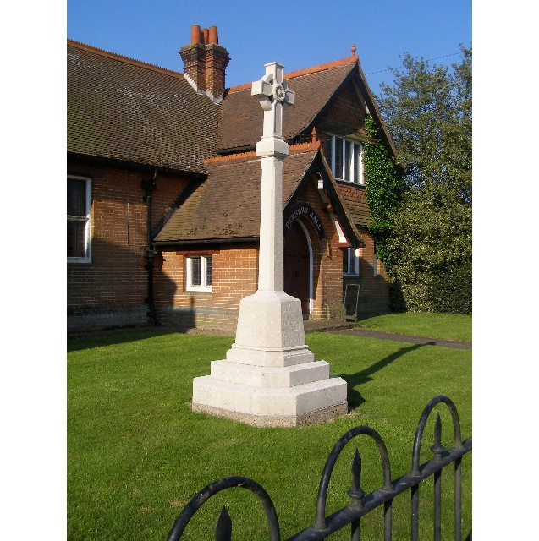
MINUTES
Meeting of the Woolverstone Parish Council
Thursday 9thMay 2024, 7.30pm at Berners Hall

- Apologies: Kathryn Deaton, Allison Glading
- Attendance: Simon Pearce, Anna Caston, Simon Kent, Jamie Mayhew, Sarah Harris, Penny Speller.
Visitor: David Radley, Agi Seemungal from Spring Lodge.

- Election of Officers
Existing arrangements to continue. Proposed Matthew March. Seconded Anna Caston
- Declaration of any prejudicial interest: none.

- Meeting Open to Parishioners
David, Radley, owner of “Soundings”, queried maintenance of Horsepond’s Green . Asked whether it was possible to a) buy Horsepond’s Green or b) have exclusive use and maintain the area. Rent or lease? WPC to place this request as agenda item for 13 June WPC meeting.
- Minutes
11th April 2024 – Agreed as accurate. proposed - Jamie Mayhew, seconded – Penny Speller
- Matters Arising
Speed Report is on agenda
PROW on the agenda
E Coli in water at Marina. Further information from Simon Harley
Berners Hall canopy has “slipped” lead. SH “in hand”.
FOW meeting 14th May.
NL (ANOB) is on the agenda
- Reports from County Councillors and District Councillors
Reports were circulated in advance of the meeting. Any questions will be emailed as neither were in attendance.
- B1456 Speed limit report – Simon Pearce
Further comments on report agreed unanimously. SP to email Helen Beresford 10th May. (Additional comments below.)

- PROW – Update – Simon Pearce
Simon Pearce shared response from Open Spaces Society. The Definitive map is the current legal situation. If landowners want to challenge this they must do so through SCC. Unless and until this is undertaken, the PROW 29 should remain open. SCC has a statutory duty to ensure the PROW is unobstructed. A new PROW Officer has been appointed. A one-month period of grace was agreed before making representation under Section 130(6) of the 1980 Highways Act.

- Working Groups – Update.
Horsepond’s Green. PM has cleared a great deal of old wood. SWLT rep visiting on 10th May to discuss updating plan for applying to National Landscapes for a grant of £700. There is a lot of work to be done by working parties to bring it back to regular use. SH to contact volunteer group. A grant may be available for projects in the NL for working groups of 8-10 for a day. Long term plan is to make it part of a chain of areas through the village to encourage biodiversity. PC feel it should be more open to the road and more obvious to parishioners.

Woolverstone to Pin Mill Footpath. SK has approached NLs concerning the marshy area between RHYC and Pin Mill. No response as yet. Land belongs to PM and he needs to be part of any conversation. JM to investigate grants through Farming and Protected Landscapes Initiative.

D-Day 80. Exhibition in Berners Hall on 8th and 9th June. Information boards almost complete. SH to make up. Some support for costs of boards from DP. FOW may sponsor some. PC may be asked to contribute. Beacon lighting on 6th June from 8.30 IHS. All parishioners welcome.

- Annual Parish Meeting on 23rd May. 7.30. Berners Hall. Refreshments provided by PC – SH

- Finance
AGAR forms completed and signed:

- Certificate of Exemption AGR 2023/24
- Annual Governance Statement 2023/24
- Accounting Statements 2023/24
- CIL Expenditure Report 2023/24
- Annual Internal Audit Report 2023/254

- Correspondence
a) Ganges variation request response shared with Holbrok PC
b) Parish meeting advertised in newsletter and on noticeboard. Village organisations asked for reports.
c) Figures on ANPR need scrutiny
d) PROW 29 ( 10 above) Report number 47664
e) Road closure for part of the day 22nd September
f) Sustainable Development Fund information was shared
g) Ancient Tree verification course on offer. SH to consider.
- Planning
DC/24/ Timbers. A laurel tree adjacent to Church Field to be reduced in height. A Cypress also to be felled. Both are C grade trees masking an A grade tree. No comment from PC.
- Berners Hall
New strip lights fitted and external lights repaired

- Friends of Woolverstone
There is to be a meeting on 14th May to discuss current projects
- AOB
- Allotments. JM raised management of allotments. Only existing holders will be allowed to continue. No new holders will be allowed, according to the managers. Nobody from the Diocese, who own the land, seems to take an interest.
- SK raised CIL funding for traffic management. Easton PC has produced a traffic furniture scheme. Could Woolverstone bid for funds via a for a traffic plan? SK to bring to next meeting.
- Woolverstone United FC play at Portman Road on 20th May. Can PC help in any way?
- SH looking to raise the profile of the village through a “Do you know” insert in the “In Touch” magazine.
- Retirement of Derek Davis from his role as reporter for Nub News. There has since been a dearth of local news.
- Succession planning. WPC need to consider preparations for the retirement of both Chair and RFO in 2026.

Date of next meeting: 13th June 2024
Meeting closed at: 21:05
Signed:

Simon Pearce. Chairman.

Additional comments 100524

Please find our additional comments on the B1456 Woolverstone to Chelmondiston Speed Report below:
"Woolverstone Parish Council has expended a lot of time and energy responding to the specifics of this report, as well as including members of the communities in Woolverstone and Chelmondiston.
There are three additional comments we would like to add to our initial response:
- In the manner in which the report is presented, our response is added to the report as an Appendix. We feel this should be more clearly signposted as an integral part of the reporting process and not an add on which the use of the term Appendix suggests.
- We feel that little attention has been paid to the high-entry speeds into the 30mph zone in the village. We were promised this would be carried out but there is no mention in the report. SCC policy does allow for the provision of 40mph buffers where the speeds entering a 30mph limit are high. The latest ANPR report gave the following information. Sadly, the battery ran out before the end of the week, so it is incomplete: Woolverstone – B1456 - 25/03/2024 – 01/04/2024
    - Total photos – 3017
    - 30-34mph – 2128
    - 35mph+ - 889
    - 40mph+ - 289
    - 50mph+ - 19
    - Fastest Speed – 69mph
- We do not recognise the description in the report of cycle use on B1456. There is no evidence given for this assertion. We would suggest that cycle use is actually quite high for leisure, for work and for sport throughout the year.
Thank you for giving us the opportunity to make representation to you about an issue which is so important to our community and consistent safety along the B1456.
Simon Pearce. Chair. Woolverstone Parish Council.
Unanimously agreed at Woolverstone Parish Council meeting on 9th May, 2024"

Addendum 190524
Dear Helen

I note I have yet to receive acknowledgement of receipt of our comments on the B1456 Woolverstone Speed Limit Report sent on 10th May. Please let me know they have been safely received and they have been added to the report.

In addition, I would like to draw your attention to further incident.

Thursday 16th May 2024. RTA in vicinity of Pear Tree Farm on double bend outside Chelmondiston in the National Speed Limit zone.

Time: approx. 9:50

Single vehicle left road on the bends and collided with tree. Vehicle caught fire. Fortunately occupant uninjured. Driver said she was driving too fast for the conditions.

Police, Fire and Ambulance in attendance.

Images below. She was lucky.
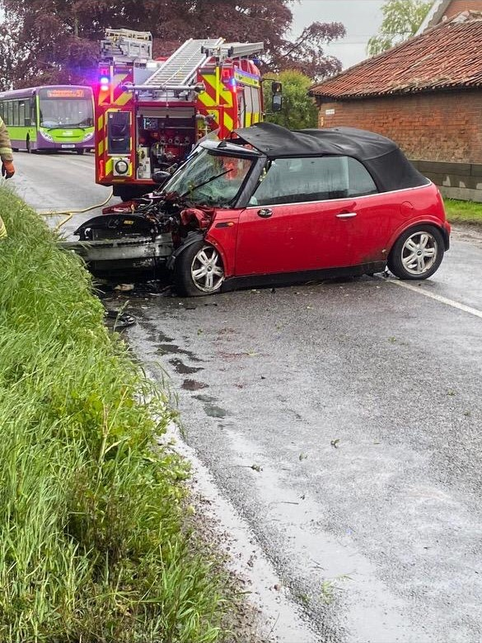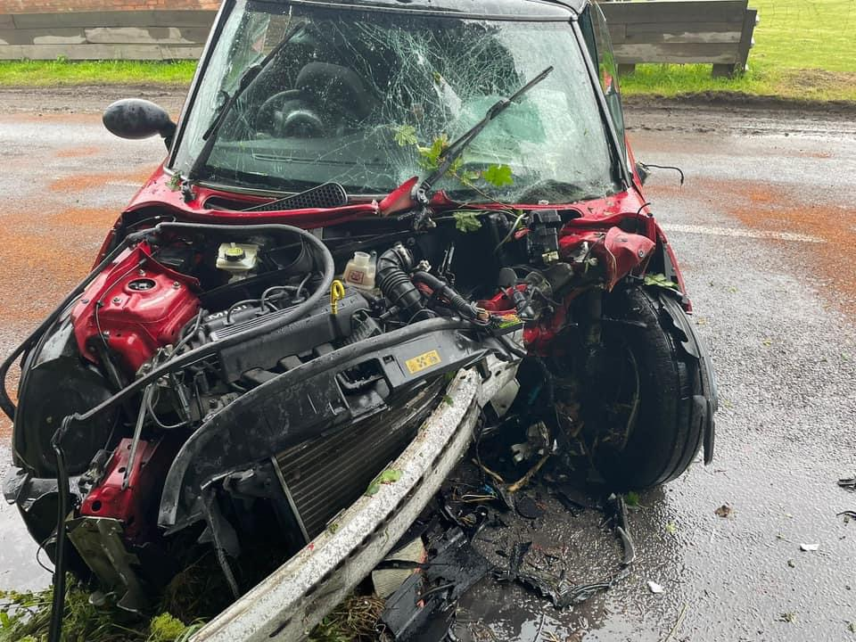

This addendum means your data set is now current. Please take this RTA into consideration in your decision making process.
Kind regards
Simon Pearce Chairman - Woolverstone Parish Council

