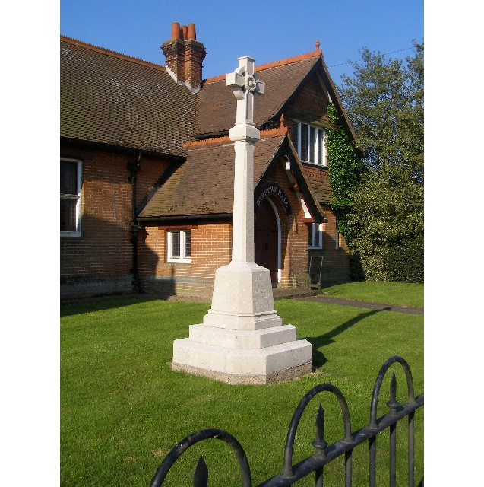

MINUTES
Meeting of the Woolverstone Parish Council
Thursday 9th October 2025 at 7:30 pm at Berner’s Hall
- Apologies : Sarah Harris, Simon Kent, Councillors Simon Harley and Daniel Potter
- Present: Simon Pearce, Penny Speller, Anna Caston. Allison Glading, Matthew March, Kathryn Deaton
- Declaration by any Councillor of any prejudicial interest in the content of the meeting: None.
- Meeting open to parishioners: None.
- Agree minutes of meeting on 11th September 2025
Proposed: Matthew March. Seconded: Allison Glading
- Matters arising:
Simon Pearce has now met Colin Hind, Operations Manager at Ipswich High School.
MDL Planning date extended to 23rd October
Horsepond’s Green working party – Saturday 25th October 10:00 – 12:00
It was agreed that we should hold off any changes on the email address.
- Reports from County Councillor and District Councillor:
Reports were circulated in advance of the meeting.
- Speed Indicator Device poles:
a. The original poles will now be used for the new devices.
b. Speed limit B1457
Despite the Parish Council being advised there would be no appeal, Sara Stafford has continued to push for this to be reviewed and been successful. We now have a further chance to appeal. Parish Council members need to advise Simon Pearce of any comments by Friday 17th October.
- Communication within the village
Friends of Woolverstone are offering to write and circulate the village newsletter. It was agreed that they would write this and be sent to Kathryn Deaton who will create an XL of emails and send this on a BCC to avoid any issues of GDPR.
- Working Groups – updates
Horsepond’s Green
Sarah Harris has purchased a strimmer multi-tool which will arrive this week. We will need to buy some Aspen (two stroke fuel). SH will be reimbursed for the amount of £319. Matthew March offered to keep this in his garage.
PROW
This was a successful meeting of stakeholders. The footpath team can only work along the designated footpath route as defined on the SCC footpath map. Hence, the boardwalk and dead hedging can only be added to the footpath which is actually much higher through the wooded area and not along the foreshore. It is planned that Graham Burgess (contractor) will start by installing the board walk in November. Following this the defined path will be cleared through the woodland and time allowed to see how wet this gets over the winter. In January dead hedging will be installed to increase biodiversity and to encourage people to stick to the path. Completion is due by April 2026.
The Parish Council have been asked to consider a wish list for further small projects within the National Landscape area of the village.
- Finance
VAT is due to be reclaimed
Current balance £11,031which includes funding for speed posts and CIL money.
Simon Pearce proposed we remain with Santander at £4.99 per month. Seconded Matthew March.
Discussion followed over a need to build a small reserve.
- Correspondence
Robin Coates – Jimmy’s Farm – working hard at developing as a Wildlife Centre. (Attended by Allison Glading)
Brian Ives has offered to get the poppy wreath for the village.
November 3rd – Alliance meeting with the planning department / Peninsula parish councillors
Peter Hyland – new resident number 6 wrote to Paul West – Cabinet Member Highways over traffic speed and a near miss his wife had. Paul West has promised SCC Highway Engineers will investigate
Roadside Nature Reserve will be cut in March / April in future instead of September
No water testing has been completed/shared this month
- Planning
Soundings were refused planning permission – changing the land they have purchased from farming to garden.
- Berners Hall
Sarah Hutton continues to look after the hall with regular hires.
- Friends of Woolverstone
Sarah Harris reported that the first meeting with the new steering committee has now taken place.
£363 was raised at the Art Show of which £85 was commission (15% of sales). They are now concentrating on the Christmas Fair (29th November) and the vision for 2026.
There is a £90 charge for annual insurance to cover events.
- AOB
Discussion followed over a Christmas Tree outside Berners Hall. Proposed: Penny Speller, Seconded: Anna Caston. Agreed unanimously. Tree to be sourced locally.
Chair, Clerk and Finance Officer roles will be discussed at the next meeting.
Anna Caston confirmed she is now a qualified Community First Responder. The Parish Council congratulated her.
Penny Speller signed up for “Important Parish Council Update – Local Government Re-organisation”. She will report back at the next meeting.

Dates of future meetings 2025: 13 Nov, 11 Dec.

