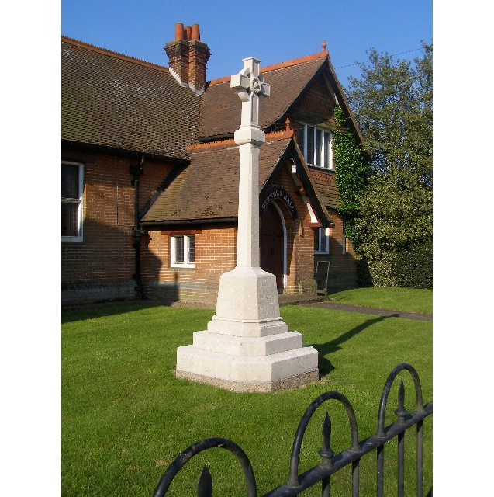
MINUTES
Meeting of the Woolverstone Parish Council
Thursday 10th April 2025, 7.30pm at Berners Hall

- Apologies: Penny Speller, County Councillor Simon Harley, District Councillor Daniel Potter
- Attendance: Simon Pearce, Kathryn Deaton, Anna Caston, Allison Glading, Simon Kent, Matthew March, Sarah Harris.
- Declaration of any prejudicial interest: none.
- Meeting Open to Parishioners Adam Peak MDL was not in attendance
- Minutes
13th March 2025 – proposed – Anna Caston, seconded – Sarah Harris
- Matters Arising
ANPR Rota updated – 19th – 26th May in Woolverstone.
- Reports from District and County Councillors
Reports were circulated in advance of the meeting. Any questions to be emailed.
Daniel Potter – District Councillor
Not present. Daniel has been unwell. Our thoughts are with him and we wish him a speedy recovery.
Simon Harley – County Councillor
Not present.
- Report of SPPA meeting with Arthur Charvonia (Friday 4th April)
Shotley Peninsula Parish Alliance (SPPA) are looking to BDC to treat the Peninsula in a more holistic way due to its unique geography. SPPA have produced a Planning Statement which covers the whole Peninsula. Arthur Charvonia accepted that all planning on the Peninsula impacts more than one village, especially along the B1456. AC has advised that he will try to ensure a small team of people will deal with all planning in the Peninsula.
- B1456 Traffic Flow Figures. Waterman for Wavensmere and SCC
Recent Traffic Report of DC/23/04109 S73 variation Ganges are unrepresentative of the traffic flows on the B1456 as the survey was conducted during a holiday and so not included all school traffic. Simon Pearce has written to Babergh and SCC Highways and is awaiting a response.
KD asked that the tidal height and impact on how passable the Strand is at certain times is also taken into account.
- PROW from RHYC to Pin Mill
Neil Lister – Countryside Officer suggested a dead hedge along the route to prevent people creating multiple paths. The landowner, Phil Mayhew, is central to any further progress. SP will contact him about concerns. While a dead hedge might help guide a walking route it does not really address the issue which is the ground underfoot. This is still wet despite the dry weather due to the two natural streams.
- Finance
Provisional annual accounts were circulated and discussed.
These will be presented at the AGM on 22nd May and will be available on the Parish website at the beginning of June.
- Working Group Updates:
a. Horsepond’s Green
Simon Kent thanked those who attended the last working group.
Simon Kent’s report was accepted and we will be receiving £700 funding as originally discussed with National Landscapes. Bird and bat boxes, child’s bench and donation for whips has been approved and paid for at £300. An adult bench, fencing stakes and a further bird box will be ordered and paid for later at £400. Replacement of equipment and weed killers were not agreed.
It was decided that the whips should not be planted until the expected fence on the southwestern boundary has been erected.
The next working party will be Friday 25th April 1030 – 1230
The Parish Council thanked Simon Kent and Sarah Harris for their work on this project.
b. Heritage Trail and Website
The website is up and running.
Simon Pearce has sent an End of Grant Report to The National Lottery Heritage Fund.
The plaques are due to be delivered to Simon Pearce on Monday and then need putting up at the various locations around the village over the next week.
- Correspondence
SPPA is now working well together over common issues.
BDC are consulting on reducing the number of people that need to be told about a planning application. This will be added as an item for 8th May
Anglian Water are wanting to come and talk about the water pipe project but to several parishes at once. Simon Pearce has suggested they organise a date.
Loft insulation offer – this will go in the Parish newsletter.
- Planning
DC/25/01349 – Tree Works
Parish Council are in agreement.
- Berners Hall
Regular number of hires.
The First Aid box is to be replaced.
- Friends of Woolverstone
Questionnaire has been finalised and this is going out with In Touch. Sarah Harris has already received one online response.
- AOB
Website – Kathryn Deaton asked for a collective name for features of the village so Horsepond’s Green can be added.
Signs – some signs are down. Allison Glading is to advise which need work.
Full Fibre -Anna Caston asked when this would be available in the village. Chelmondiston which is further along the road has it already.
Date of next meeting:
8th May (Kathryn Deaton and Allison Glading gave apologies in advance)
22nd May – Annual Parish Meeting
Meeting closed at
Signed:
Simon Pearce. Chairman.

