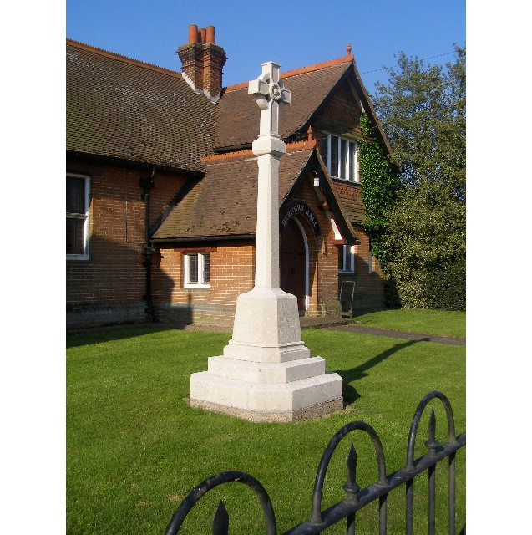
MINUTES
Meeting of the Woolverstone Parish Council
Thursday 11th December 2025, 7.30pm at Berners Hall

- Apologies: Allison Glading, Simon Kent, Councillor Harley, Councillor Potter
- Attendance: Simon Pearce, Kathryn Deaton, Anna Caston, Penny Speller, Sarah Harris, Matthew March
- Declaration of any prejudicial interest: none.
- Meeting Open to Parishioners: none.
- Minutes
13th November 2025 – proposed – Anna Caston, seconded – Matthew March.
- Matters Arising
Cycle plan – Simon Pearce wrote on behalf of the Parish Council and raised our concerns at the proposed changes to the implementation of the cycle path.
- Reports were circulated in advance of the meeting.
Daniel Potter – District Councillor
Not present. No questions.
Simon Harley – County Councillor
Not present. No questions.
- B1456 Speed Reduction Re-application.
This has been approved but the official notification is still pending. A letter, flowers and bottle will be sent to Sara for her determination is getting this case re-opened. It has been advised that this will take 9-12 months to implement. Councillor Harley has £9000 to contribute to this, the Parish Council will need to add to this using CIL monies.
- Roles of Chair / Clerk and RFO – 2026 and 2027 – Anna Caston
Jo Hazelwood Freston Parish Council Clerk: 8 - 10 hours per month and charges £14 per hour. (Also covers Holbrook).
Katie Davies – Chelmo Parish Council Clerk – starting the SALC course in January. She would consider covering Woolverstone. Anna Caston will discuss this further with her.
This is to be collated and to be the key discussion point in January. Kathryn Deaton proposed delaying the January meeting to 15th, seconded by Anna Caston.
Sarah Harris will speak to Dinah Bedwell, Shotley Clerk.
- Communication within the village
The newsletter will come from FOW from February next year or possibly January if they can meet before Christmas.
- Working Groups – Update:
a. Horsepond’s Green / Marina Road
Penny, Sarah, Simon and Rufus met on 22nd November and planted a twisted willow donated by Jay. More whips were also planted. The area is looking very good.
Graham Speller will fix the gate as this simply swings open.
Marina drive still needs further strimming.
b. PROW – RHYC – Pin Mill
There is a big improvement but there remains a further phase to complete this.
- Finance
General £5860.91 NB The general fund paid out £617.97 to complete the Heritage project.
Grant for speed posts £2,000
CIL Balance £3509.87
Horsepond’s balance £50.00 due to reclaimed VAT
Total at bank £11420.78
The precept will need to be submitted by 31 January 2026. This will be decided at the next meeting.
- Correspondence
Ed Bastow has called Spring Lodge regarding the school dinner smells but they have not replied. Joe Caston has also written. Ed Bastow has now contacted Environmental Health as nothing has been actioned.
Alan and Carol Hughes have moved and have been removed from the mailing list.
Tracey Woolnough has advised sugar beet is on footpath number 21. This is due to be removed shortly.
Simon Pearce has supported Jane Every about the state of the fabric of the Widows Homes.
- Planning
MDL Planning still shows as awaiting decision.
- Berners Hall
There have been very few rentals.
FOW have offered to assist with clearing the stage area of Berners Hall.
- Friends of Woolverstone
Good Christmas Fair with carol singers on the stage who then brought people and also contributed to sales.
Income £543: £105 stall holders, £238 Raffle, and £200 refreshments. Small items were bought from this at £38.
Discussion followed over getting more people involved from the village. A lot of people attending came from outside the village.
More ideas are being considered by FOW to bring the village together.
- AOB
Sarah Harris has established a Google Drive with folders as a trial for the Parish Council to use going forward. This will be run as a trial alongside the current system with this coming in to effect from 14th May when Simon Pearce stands down as Chair. At the meeting on 12th Feb a demonstration will be run by Sarah Harris and Kathryn Deaton to the rest of the council.
Anna Caston has started as First Responder.
Matthew March proposed that we employ a Parish Clerk, it was decided this would be discussed further at the January meeting when we had further specific information regarding rate of pay and employment type.
Dates of future meetings 2026: 15 Jan, 12 Feb, 12 Mar, 9 April, 14 May, 11 Jun, 9 July, 10 Sept, 8 Oct, 12 Nov, 10 Dec. Annual Parish Meeting 28th May.
Meeting closed at 9:20
Signed:

Simon Pearce. Chairman.

