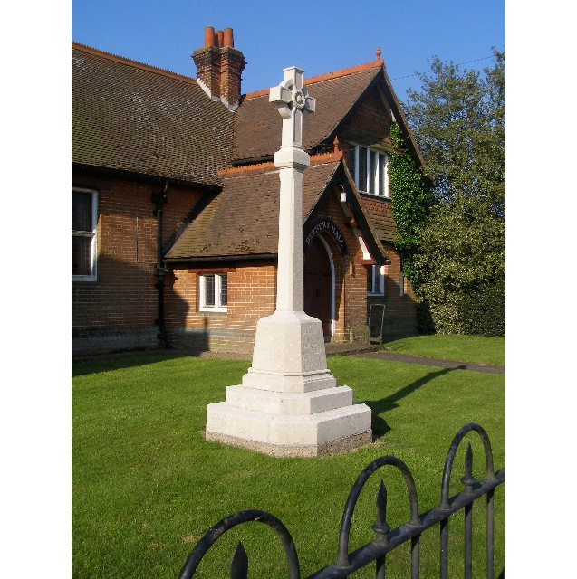
Meeting of the Woolverstone Parish Council
Thursday 13th February 2025, 7:30 pm at Berner’s Hall.

1. Apologies: Kathryn Deaton, Anna Caston

2. Attendance: Simon Pearce, Allison Glading, Simon Kent, Penny Speller, Matthew March, BDC Councillor Daniel Potter and SCC Councillor Simon Harley

3. Declaration of any prejudicial interest: No declaration of interest

4. Meeting Open to Parishioners: No parishioners present

5. Minutes
9th January 2025 - proposed Allison Glading, seconded - Penny Speller

6. Matters Arising
SCC reported no issue over PROW concerns

Item 17 - address list - SH to request updates - Response Box initiative to be pursued

Mtg with MDL arranged for 13th March. Topics to include - Tree Survey and resulting actions, and potential developments in leisure opportunities.

Defibrillator availability in process of assessment.

7. Reports from District and County Councillors
Reports were circulated in advance of the meeting.

County Councillor Report - Simon Harley
Discussion on the creation of a Strategic Authority, role of Mayor, level of accountability to local people and the impact of this reorganised representation on the county.

District Councillor Report - Daniel Potter
Discussion on housebuilding requirement and the inherent difficulties in meeting targets e.g., skills shortages creating delays in project completion.

Availability of grants for amenity improvements - e.g., secondary glazing for Berners Hall
Need for project manager to initiate and source funding from, for example, Winter Grant Funding, Locality Grant and BDC CIL money.

8. PROW - Update
Concerns reported to SP about difficulties with the gate. Gate needs to be pushed open - counter intuitive.
SP had requested that the PROW team provide a definitive point where footpath ends.

9. Additional SID devices
Meeting in first week of March at Berners Hall to assemble devices. SP to circulate date and time.

Speed Management.
Discussion on process and potential strategy following County Council rejection of speed limit reduction between Chelmondiston and Woolverstone. Suggestions include use of SCC Speeding Tool, commissioning of an independent safety survey as completed at Freston Crossroads, use of Community Speedwatch, and funding from CIL etc

10. Finance Report (provided by AG)
In January, we paid £900 for website design and £180.01 for website registration for the blue plaque scheme. Both amounts are to be deducted from the lottery project moneys.
We received the grant towards the posts for the speed signs from Councillor Harley.
Currently our balances are: -
Parish Council £6491.99 includes the grant for the speed signs posts
CIL £2754.27
Lottery £3836.29
VAT currently amounting £180.60 (parish council), and £755.60 (CIL) will be claimed towards the end of the financial year.

11. Working Groups

Horsepond’s Green - Next working group March 8th 10.30 to 12.30

Litter pick – Sat 1st March 10:30

Roadside Nature Reserve - post to be provided by SK, painted, and details transferred from previous post.

Heritage Trail - Details on www.woolverstone.org. - Disks are ready to be printed. Discussion on whether planning permission is relevant for posts.

12. Correspondence

1 No reply yet from Babergh Planning to Shotley Peninsula Parish Alliance regarding their request to be considered as a relevant entity for planning correspondence purposes.

2 Widows Homes
The prompt response from Keeley Whitlock, Customer Resolutions Officer, to SP's enquiry on behalf of a resident of the Widows Homes, Main Road was appreciated. No response, as yet, from resident has been received.

13. Planning
Anglian Water - Hedgerow removal and reinstatement. SP will respond as per the previous application. There will be emphasis on replacement with mature hedgerow.

14. Berners Hall - Electrical work has been undertaken.

15. Friends of Woolverstone - meeting planned

16. AOB
None presented

Date of next meeting: 13th March

Signed:

Simon Pearce. Chairman.

