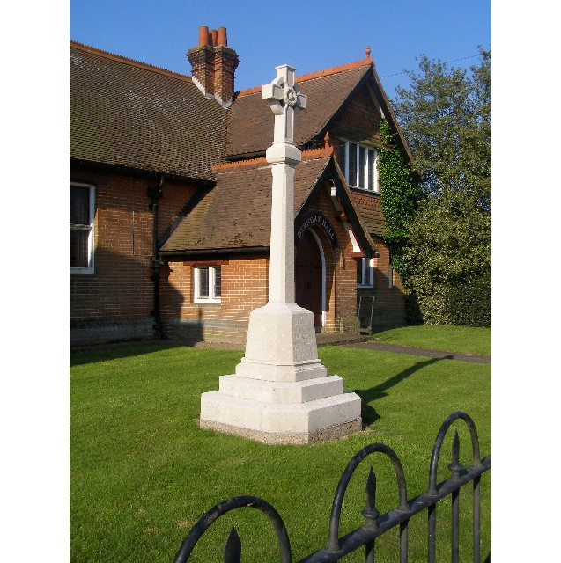
MINUTES
Meeting of the Woolverstone Parish Council
Thursday 10th July 2025, 7.30pm at Berners Hall

- Apologies: Simon Kent
- Attendance: Simon Pearce, Matthew March, Allison Glading, Penny Speller, Sarah Harris, Kathryn Deaton, Anna Caston, Simon Harley
- Declaration of any prejudicial interest: none.
- Meeting Open to Parishioners None
- Minutes
12th June 2025 – proposed – Allison Glading, seconded – Kathryn Deaton
- Matters Arising
Anglian Water met with villagers in Berners Hall, last Monday to talk about the new water pipe being laid.
New estate manager starting at IHS in September.
- Reports from District and County Councillors
A reports from SH was circulated in advance of the meeting.
Daniel Potter – District Councillor
Not present.
Simon Harley – County Councillor
The government will make a decision in September on the outcome of the changes to council.
- Posts for Elan City SID and solar panel
These have to be taller for the solar panels. Simon Pearce has not heard anything from Highways and Simon Harley suggested contacting them and pushing this forward, he will copy in Simon Harley to help move this forward.
- External hard drive – WPC file transfer
It was agreed that this should be purchased. SH will look at products.
- Working Groups Update
a. Horsepond’s Green
Simon Kent is investigating if we can secure the money from National Landscapes for the bench.
Sarah Harris will look in to costing and purchasing a strimmer.
Rufus has completed work on 2/3 rds of the existing bench.
Sarah Harris will spray off the Hemlock
b. PROW – RHYC to Pin Mill
Waiting for confirmation from DEFRA on funds for this. Neil Lister has been in touch with Simon Pearce.
c. Heritage Trail and Website
Suffolk Sounds did a 10 minute piece.
- Finance
No change since last month.
- Correspondence
Jane Evry – sign post issue that Simon Pearce is managing. Discussion over the planned development at MDL.
Peninsula Parish Alliance Meeting – next Tuesday.
Tattingstone A137 closed Monday – 25th July overnight.
Water Testing is going ahead at Woolverstone and three other sights around the Peninsula.
Katie Jarrett – PC – issued an circulated a document.
Sara Stafford wrote to SCC about the level and volume of traffic. She has taken a different approach to the PC.
- Planning
MDL:
Sycamore Trees – application to cut some down.
There was no issue with this.
Pods and Lodges – some initial thoughts:
There is no mention of the junction with the road and visibility.
Bus stop – they advise there is a reasonable service. This is not the case.
Five ancient oaks – these are not veteran – they need protecting.
Light pollution.
Pods – are they self-contained? Do they have facilities and how many do they sleep?
The Parish Councillors will review and return comments to Simon Pearce to collate. This needs to be by Thursday 17th July. He will collate and send to the PC on 24th July.
- Berners Hall
Sarah Hutton is continuing to run this.
- Friends of Woolverstone
Art Show - September
- AOB
SWARCO – Simon Pearce is in conversation on securing the traffic data
Date of next meeting: 11th September 2025
Meeting closed at
Signed:
Simon Pearce. Chairman.

