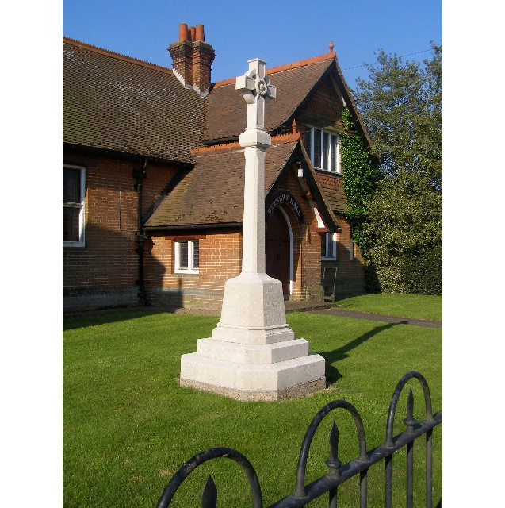
MINUTES
Meeting of the Woolverstone Parish Council
Thursday 12thJune 2025, 7.30pm at Berners Hall

- Apologies: Penny Speller, Sarah Harris, Matthew March, Anna Caston
Simon Harley, Daniel Potter,
- Attendance: Simon Pearce, Kathryn Deaton, Allison Glading, Simon Kent
- Declaration of any prejudicial interest: Kathryn Deaton for point 4.
- Meeting Open to Parishioners – Mike Deaton – Solar Panels
Mike Deaton asked for confirmation that solar panels can be fitted to Springfield on the rear of the property. He does not believe that these would be visible from the road or require planning.
Simon Pearce advised Fairwinds had applied in 2020, it was denied by Babergh District Council Planning Officers due to it being in a conservation area and to the front of the property. Planning advised it did not enhance / fit in with the local area. However, there was advice that if the panels were to be located on rear facing roof this would be received favourably. Simon Pearce suggested an informal chat with Babergh and will look into some contact details.
- Minutes
8th May 2025 – proposed – Simon Kent, seconded – Simon Pearce
- Matters Arising
Simon Pearce has spoken to Michael Smith at Anglian Water – he will be available at Berners Hall on Monday 30th June at 7.30pm to explain the plans for the new water system.
Richard Wrinch – Chair SPC gave Simon Pearce a copy of a letter submitted on the handling of the planning at Barrelman’s Point – Section 73 application passed 30th March 2025. Simon Pearce will write a letter from WPC to support this and to add the points we have regarding the failure to take account of the unrepresentative traffic data. There is concern about the unsubstantiated views of Ganges Councillor, Derek Davis, who spoke at the Planning Committee meeting and wrote in the In Touch magazine.
Road Closures were shared on Facebook and will go in the village newsletter.
No response from Neil Lister regarding the footpath from RHYC to Pin Mill.
- Reports from District and County Councillors
No reports due to sickness.
Daniel Potter – District Councillor
Not present.
Simon Harley – County Councillor
Not present.
- Annual Parish meeting – Feedback
This ran smoothly but with a low attendance. If anyone can think of strategies to encourage better attendance, please share your ideas.
- Working Groups – Update.
a. Horsepond’s Green
Sarah Harris advised every third Monday during the summer months 6.30-7.45, every third Saturday in winter months 10.30-12.00.
Simon Kent has a quote for a bench - £700. We only have £400 left in the kitty but National Landscapes may be able to provide further funding. Allison Glading advised there will be VAT back so may only need about £160. Okohaus will continue to support tidying the area during lunch periods.
Discussion followed over the boundary with No 24 Main Road an HG as the property has now been sold. Simon Kent will try and establish who owns and so is liable for the “fence”.
b. Marina Drive
Sarah Harris to speak to Phil Mayhew about strimming and tidying this area.
b. Heritage Trail and Website
Tom Taylor National Lottery Heritage has now recorded the project as complete and congratulated Simon Pearce. Ipswich Institute are coming to walk the trail as a group. RHYC, MDL, Monimar, Orwell Stores, Hollingsworth’s and Sutton Community Shop all have copies of the trail leaflet. The councillors congratulated Simon Pearce for his hard work.
- Finance
CIL Balance £3509.87
Grant for SID posts £2000
The above needs to be spent and Allison Glading will check the deadline for this. Simon Pearce asked the councillors to consider how we use the funds.
Horsepond’s Green Grant - £300 received and £300 spent
Parish Council Balance is £5714.52 with balance after lottery project costs £5096.66.
We received Precept of £1600. We spent £189.16 on SALC membership, £25.11 on auditor gift and stamps and £193.20 on lawnmower servicing.

VAT of 32.20 will be reclaimed before year end.
Lottery. Carried forward was £ 255.63
We have spent £1152 on plaques and £133.27 on leaflets, making the standing balance of £-1029.64
VAT of about £400 will be reclaimed and the parish council pay the outstanding amount.

- Correspondence
Shotley Peninsula Parish Alliance:
Parish and Police Forum 25th June 7.30 Capel Library.
Government Reorganisation – May 2026 we will vote for a Mayor of Suffolk and Norfolk, Two County Councillors from Suffolk and two from Norfolk will be selected without a vote. Unitary authorities should have a population of about 500,000 but Suffolk has 750,000. There is a divide between County Council and District Council on whether there is one large unitary authority or several. Leaflets are available for circulation. Simon Pearce will include this electronically to the villagers.
- Planning
Soundings – question on parking, size of the gravel area, fencing adjacent to Horsepond’s Green and trees lining the allotment.
- Berners Hall
This continues to run smoothly.
- Friends of Woolverstone
Volunteers to help organise events: Allison Glading, Julie Pearce, Sophie Spiers, Adam Owens. A meeting will be planned to discuss possible events.
- AOB
Simon Kent sent apologies for the next meeting.
Simon Kent raised the issue of the HIS gates near the church which still need replacing as they are not in line with planning permission. Simon Pearce will speak to the new estate manager at Ipswich High.
Simon Kent queried how we could progress the issue of the narrow pathway in the village and the potential safety issues. He asked that we start to consider what could be done. Simon Pearce advised Paul West was in charge of highways and writing directly may be better.
Date of next meeting: 10th July
Meeting closed at 21:55
Signed:
Simon Pearce. Chairman.

