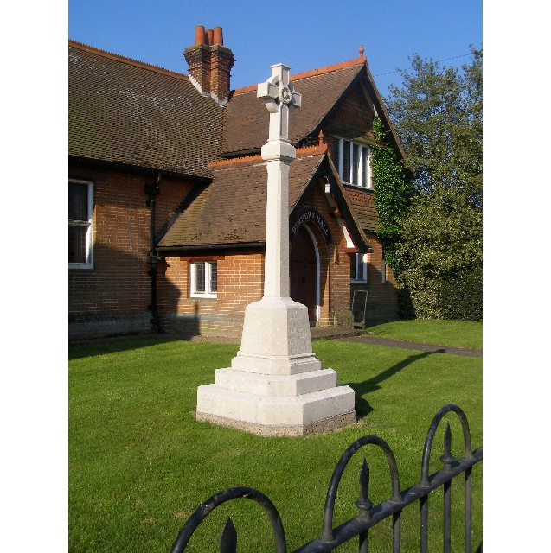
MINUTES
Meeting of the Woolverstone Parish Council
Thursday 13th March 2025, 7.30pm at Berners Hall

- Apologies: County Councillor Simon Harley, Simon Kent and Penny Speller
- Attendance: Simon Pearce, Kathryn Deaton, Anna Caston, Allison Glading, Matthew March (left after point 7), Sarah Harris, District Councillor Daniel Potter
- Declaration of any prejudicial interest: none.
- Meeting Open to Parishioners – MDL – Apology
- Statement re: Affordable Housing in Woolverstone – Matthew March
MM has spoken to a number of people involved in affordable housing. These properties would require two cars to enable the housing to work, breadwinner and parent caring for children. He now feels, alongside Elspeth Iskander who initially proposed this, that Woolverstone is not a good location: facilities, public transport and car dependency (not viable for low income). Within Geoff Mayhew’s proposed development there is one affordable house and one shared ownership.
The council thanked MM for his hard work on this project and supported his conclusion.
- Minutes
13th February 2025 – proposed – Matthew March, seconded – Allison Glading
- Matters Arising
SID Device – postponed to April.
Arthur Charvonia BDC Chief Executive, – meeting Friday 4th April to meet Shotley Peninsula Parishes Alliance.
Anglia Water – responded requesting that the hedge is reinstated with established whips. Simon Pearce will write AW to arrange the offered public meeting at Berners Hall to explain the project.
- Reports from District and County Councillors
Reports were circulated in advance of the meeting.
Daniel Potter – District Councillor
Circulated in advance.
Suffolk County Council to take over the operation of Suffolk Libraries. Suffolk Libraries are opposed to this, supported by 20,000 signatures on a petition. it is not clear what services will continue or be cut.
Simon Harley – County Councillor
Not present.
- Additional SID Devices and Signage for the Village
A village name plate will be put up again at the Freston end of the village. Simon Pearce will query the indicated cost as this, as presented, seems exorbitant.
- Finance – Allison Glading
I have re-claimed the VAT since the last meeting and am awaiting payment.
Lottery project – since last month we have paid out £3426.50 with a further amount of £960 outstanding. I envisage there will be an overspend of £520.21 on the lottery project.
Woolverstone Parish Council will fund half and Friends of Woolverstone the other half of any overspend. Proposed – Simon Pearce, Seconded – Sarah Harris. Agreed unanimously.

Currently balances are:
Parish Council £6491.99 which includes the grant for the speed signs
CIL - £2754.27
Lottery - £439.79 with one invoice due (see above).
- Working Groups – Update.
Horsepond’s Green
The last day of maintenance is now complete to secure the funding from Suffolk Coasts and Heath.
A sign outside the area will allow people to scan a QR and read about the area along with what can be found in the area.
A page on Horsepond’s Green will be added to the Parish Council website, this will be a work in progress.
A final date to meet and work on the area this Spring is Saturday 5th April at 10:30 – 12:00.
The owners of the house adjacent to the plot has purchased the land to the rear of Horsepond’s and are potentially installing a fence across the back. Further whips are to be planted in this area.
Heritage Trail and Website
The website is going live tomorrow, Friday 14th March. The Parish Council thought this looked excellent.
The Heritage trail itself will be live by the end of the month.
- Correspondence
Simon Pearce responded to a resident’s letter.
James Cartlidge is organising a meeting about Neighbourhood Planning.
Babergh Public Realm thanked the parish for our litter pick.
ANPR Rota – 12-19th May.
Minutes from the Police Forum.
Response from Paul West about the traffic figures for accidents along the B1456 being incomplete after being chased by Shotley Peninsula Parishes Alliance
- Planning
None.
- Berners Hall
Simon Pearce secured a collapsable wheelchair using Peninsula Treasure Chest. This was donated and will be available for those wanting to use Berners Hall, in particular for those with restricted mobility attending our Warm Thursday coffee mornings.
- Friends of Woolverstone
Sarah Harris has prepared a Village Social Events Questionnaire. Discussion followed over the content. Arrangements are being made for delivery at the beginning of April.
The questionnaire can be completed using a QR code or by completing the questionnaire and putting this in a temporary post box at Berners Hall.
- AOB
Anna Caston is training to be a First Responder covering Woolverstone and Chelmondiston. Equipment costs £2000 and so funding will be needed. Ways this could be achieved were discussed with lots of support.
Date of next meeting: 10th April 2025
Meeting closed at 21:03

Signed:

Simon Pearce. Chairman.

