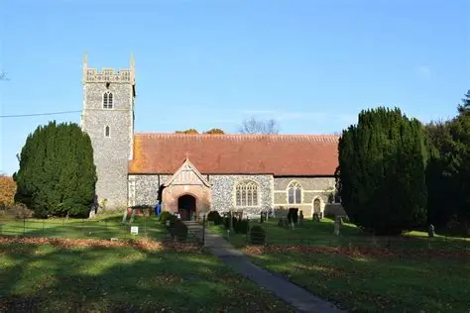

Minutes
Meeting of the Woolverstone Parish Council
Thursday 9th April 2026
7:30pm, Berners Hall, Woolverstone

- Apologies – Dcllr Potter

- In Attendance – Simon Pearce, Penny Speller, Matthew March, Sarah Harris, Katheryn Deaton, Allison Glading, Simon Kent
- Declaration of Interests
None
- Public Forum
No members of the public in attendance
- Minutes 12th March 2026
The minutes were agreed to be a true record and were signed by the Chair. Proposed by Cllr Gladding, Cllr Harris seconded, all in agreement.
- Matters Arising
All documents/planning and correspondence will be put into Google Drive in the future for all Cllrs and the Clerk to have access to.
The Easter egg hunt was a great success with many families attending.
The planning application reported in the January 2026 meeting of a permanent sitting caravan was questioned as it appears to be a more permanent dwelling.
- Reports from the DCllr and the CCllr

All reports were circulated to Cllrs prior to meeting.
CCllr Simon Harley – CCllr Harley gave his final report, which included speeding, rights of way funding and the highways budget. Thanks were expressed by the Parish Council for his work over his time as CCllr.
DCllr Potter – Cllr Pearce ran through the report which included devolution and alternative plan funding.

- Working with Google Drive
It has been noted that the Parish Council's current practices do not comply with established data guidelines, which require the use of a .gov email address. The use of personal email accounts is now outside these guidelines; however, council-dedicated free email accounts are permitted. A final decision regarding future email usage will be made once further information has been obtained.

Councillor Pearce proposed the development of a WhatsApp Policy to regulate the use of the Parish Council's WhatsApp group. The proposal was seconded by Councillor Kent and unanimously approved.

- Parish Clerk Employment
The Clerk formally started post on the 1st of April.
Cllr Pearce proposed the Annual Meeting and the monthly PC meeting to be set for the same day (May the 21^{st)} , Cllr Glading seconded, all in agreement.

- Finance
Cllr Glading reported that an item was omitted from the budget and this has now been rectified. The bank figures were ran through with no changes from last month.
Cllr March enquired about the cost of servicing the PC lawnmower, Cllr Pearce ran through the costs and broke down the costs and the requirements for them.
- Working group update

- Horseponds Green/Marina Rd - Cllr Kent updated the PC on grants available and the incoming grant of £700 and suggested new fence posts to formalise the parking area. Appreciation was extended to everyone who contributed at the previous working party. The dates for upcoming working parties have been confirmed as 18th April, 16th May, and 20th June. Councillor March noted that the noticeboard outside Horseponds appears worn and suggested that the Parish Council may wish to consider purchasing a new one in the near future.
Cllr Deaton mentioned that Marina Road requires some attention and Cllr Kent suggested that the next working party date is utilised to concentrate on Marina Road.

- Heritage Trail - The Parish Council is yet to receive the plaque mock up and this will be presented to the PC as soon as it is available.

- Correspondence

- The formal precept amount has been received
- The Suffolk Highways forum date has been set
- The election has been set for the 7th of May, and the information will be posted on the Noticeboard.
- Planning decision for Mayhew farm was not required.
- Email regarding Suffolk three unitary authority.
- Parish Alliance information.
- Email from Highways regarding the progression of the Speed limit.
- CIL return is due for the 30th of June.
- The dredging at the Marina has been continuing.
- There has been no known progress on the Marina application despite the deadline passing.

- Planning

No new Planning Applications

- Berners Hall
The meeting has been set for the 16th of April and it was decided that Cllr Pearce will be the spokesperson and invitations will be sent out.

- Friends of Woolverstone
A Garden Party is going to be held in June by invitation only.

- Any Other Business
There will be a classic car show in September at the school, and the Art show has been confirmed

Date of Next Meeting – 21st May 2026
Meeting Closed at 21:25

