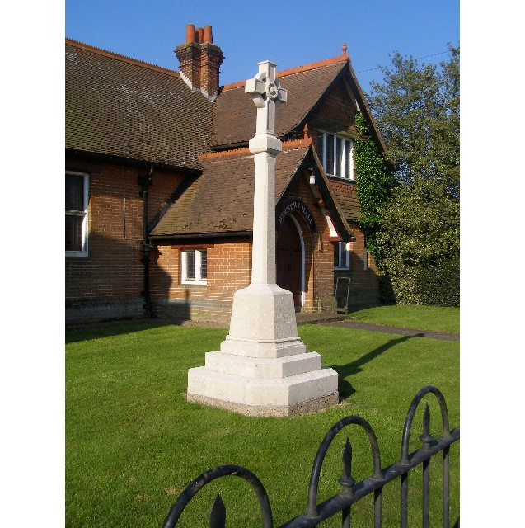
MINUTES
Meeting of the Woolverstone Parish Council
Thursday 12thFebruary 2026, 7.30pm at Berners Hall

- Apologies: Penny Speller, Councillor Simon Harley, Councillor Daniel Potter
- Attendance: Simon Pearce, Kathryn Deaton, Anna Caston, Allison Glading, Simon Kent, Sarah Harris, Katie Davies for Point 4.
- Declaration of any prejudicial interest: none.
- Meeting Open to Parishioners
Katie Davies Parish Clerk to Chelmondiston attended to see how we operate and for us to meet her.
Everyone on the Parish Council introduced themselves and their areas of interest. Katie Davies did the same.
- Minutes
15th January 2026 – proposed – Allison Glading, seconded – Anna Caston
- Matters Arising
MDL Tree survey – Simon Pearce contacted MDL to highlight the discrepancy in the documents as to the level the tree is being cut to. They have said they will follow the tree survey advice.
- Anna Caston - Speed Limit survey – Woolverstone to Chelmondiston – 75 replies.
Very quick and easy to use.
- Reports from District and County Councillors
Reports were circulated in advance of the meeting. Any questions will be emailed as neither were in attendance.
Daniel Potter – District Councillor
Not present.
Simon Harley – County Councillor
Not present.
- Working with Google Drive – Feedback
AG – Finance working well
SP – SH will assist in getting this running for him
SK – Still to try
- Parish Clerk – Anna Caston
Proposed by Anna Caston - Katie Davies is employed as Parish Clerk. Seconded Sarah Harris.
Ideal start date is Monday 2nd March for a trial period of six months.
- Finance – Allison Glading
General £5900.93
Grant for speed posts £2000
CIL Balance £3509.87
Horsepond’s Balance £50
Total at Bank £11460.80

- Working Groups Update
a. Horsepond’s Green / Marina Road – Sarah Harris / Simon Kent
The January working party involved planting of new hedges. SK suggested a donation to Woodland Trust.
Construction of the bench has started.
National Landscapes – SK applied for a grant for bollards / fencing /maintenance of Horsepond’s Green.
Next working party date is 21st February. This is to install bird and bat boxes.
Anna Caston proposed opening up the front of Horsepond’s Green to make it a more open space. This was discussed.
- Correspondence
Tickets for Tudor voices – launch event Saturday 28th February, 1pm – 4pm at the Hold. Ticketed event but no charge for tickets.
A live performance is expected in May beside the river and a talk at Berners Hall.
Harkstead PC requested £12.50 for the water sampling. This was agreed.
DEFRA Tree Survey
John Ambrose, Chair Holbrook PC has asked if we can share the training with the SID Sign suppliers.
BDC’s call for sites was discussed. They will produce a SHLAA and consider how this fits with a development plan.
Community PC raised concerns over people lighting fires.
SALC are producing a series of fact sheets to guide Parish Councils.
12th March – next quarterly meeting for joint Shotley Peninsula Parish Councils.
Confirmation precept received.
Simon Pearce will write to Anglia Water about damage to the verges and ask for re-instatement along with repair to the verges on marina road where they are turning vehicles round.
- Planning
MDL have until 18th February to address concerns received from consultees.
- Berners Hall
The management committee is set up as required by the original covenant of the gift of the hall to the village. It is a charity.
FOW are happy to find a number of people to help run the building and to modernise the running of this i.e.: online bookings, digital one-time code key safes.
- Friends of Woolverstone
Planning a Heritage Trail Easter Egg Hunt Good Friday – Adults and Children. At 11am return to Berners Hall for tea / coffee. Easter Eggs for children.
Glenham Hall are talking to Ipswich High School about holding a Classic Car Show.
Newsletter starting on a regular basis which will come out at the end of the month.
- AOB
Litter Pick – Saturday 7th March. Anna Caston and Kathryn Deaton are unable to attend so will arrange to cover Marina Road / RHYC at another time and confirm once done.
Date of next meeting: 12th March 2026
Meeting closed at 21:45

Signed:

Simon Pearce. Chairman.

