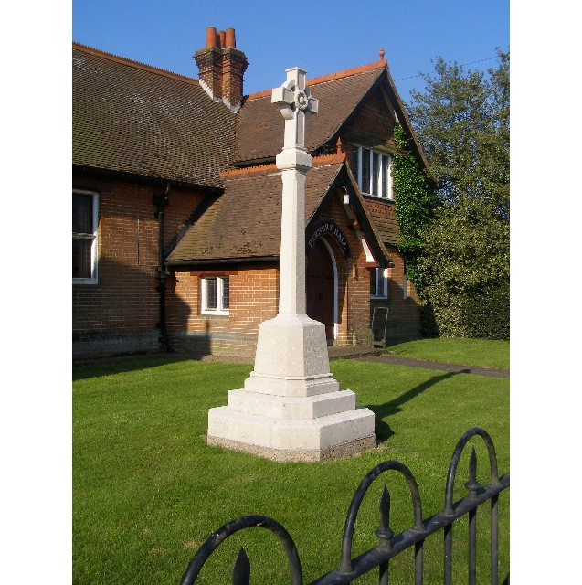
MINUTES
Meeting of the Woolverstone Parish Council
Thursday 13th March 2026, 7.30pm at Berners Hall

- Apologies: Penny Speller, Anna Caston, Councillor Simon Harley
- Attendance: Simon Pearce, Kathryn Deaton, Simon Kent, Allison Glading, Matthew March, Sarah Harris.
- Declaration of any prejudicial interest: None.
- Meeting Open to Parishioners – None
- Minutes
12th February 2026 – proposed – Allison Glading, seconded – Sarah Harris
- Matters Arising
Tudor Voices – told the story of the death of Richard Astill at Woolverstone in 1518 - at The Hold on 28th February, a number of the villagers attended and thought it very good. They will be holding a similar event on the river between RHYC and Pin Mill in May.
Litter Pick took place 7th March in Woolverstone. Main Road, Harkstead Lane, Mannings Lane cleared.
- Reports from District and County Councillors
Reports were circulated in advance of the meeting.
Daniel Potter – District Councillor
Not present.
Simon Harley – County Councillor
Not present.
- Working with Google Drive - Feedback
All members of the parish council have now started using Google Drive.
- Parish Clerk – Terms and Conditions of employment. Contract of employment and job description.
There was discussion but this is not minuted due to confidentiality.
To confirm the position. Proposed: Kathryn Deaton. Seconded: Matthew March. The vote was unanimous.
- Finance – Allison Glading
The budget has been completed for the coming year:
The Parish Council wished to thank Allison Glading for her work.
- Working Groups – Update.
a. Horsepond’s Green / Marina Road – Sarah Harris / Simon Kent
The bench bases have been installed today. The bench will follow once this is set, Simon Kent is working to get this done next week. There will be lettering engraved on the bench: Woolverstone PC and National Landscapes.
The remainder of the planting took place and bird boxes were put in place.
The next working party will be 21st March at 1000-1200
b. Heritage Trail – Robert Astill – Blue plaque
Simon Pearce will present the PC with a mock up of this plaque. It was suggested this should be placed by RHYC / near to the pathway to Pin Mill.
- Correspondence
Invite to the Babergh Council meeting in Great Cornard.
SPPA Meeting this afternoon – Robert Hobbs – Strategic Planning Babergh – explaining their development plan for the next 20 years. PC’s will be asked for their input in May. Website for call for sites has been updated.
Jay Miller has offered to assist with Berners Hall.
Planning was granted for the phased construction of the cycle paths associated with the building of 22 new houses in Woolverstone.
A certificate of Lawful Development was granted at No 3 Main Road for the siting of a caravan.
- Planning
No new planning applications.
- Berners Hall
Allison Glading has seen Sarah Hutton and discussed the signatories on the Berners Hall Management Committee account. There are currently three: Sarah Hutton, Joan Patching and David Hazelwood. A new chair is required as a matter of urgency. Advertising will take place for a meeting regarding the future of Berners Hall on Thursday 16th April 7pm - 8pm – WhatsApp, Newsletter and Facebook.
- Friends of Woolverstone
Easter Egg Hunt has been advertised and will be the first major event.
Classic car show has been advertised.
- AOB
Allison Glading advised footpath outside the Widows Homes was slippery and covered in moss.
Allison Glading advised the memorial was cleaned in 2021. The lichen has re-appeared but was supposed to have been treated and this was expected to last 10 years. Simon Pearce will write and ask for advice.
Date of next meeting: 9th April at 19:30
Meeting closed at 2140
Signed:

Simon Pearce. Chairman.

